TERMS OF REFERENCE (TOR)

For

**Uttara University Transport**

**Component:** Transport Management System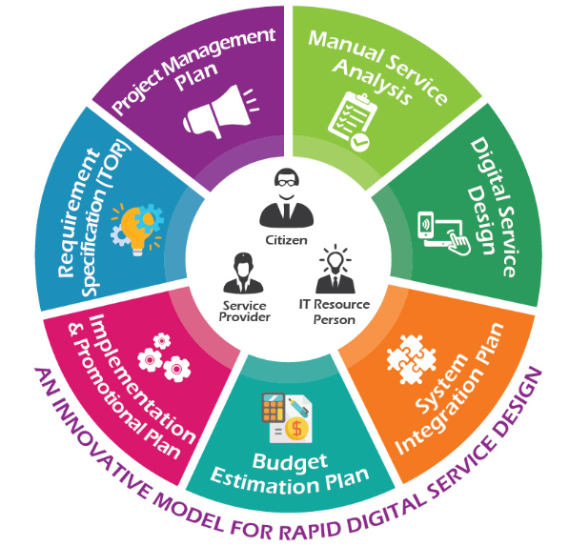

**Prepared By**

**Venue:** Uttara University, Uttara, Dhaka.

**Date**: 23-30 November, 2019

**Organized By:**Transport Management Group, 43 batch, CSE Department, Uttara University

**Advised by:**

| Name | Designation | Ministry/Division/Organization | Phone/Mobile No. | Email |
| --- | --- | --- | --- | --- |
| Md Tomig Uddin Ahmed | Guest Faculty Member | Uttara University | 01711962245 | tomiz20929@yahoo.com |

**Designed & Planned by:**

| Name | Designation | Organization | ID |
| --- | --- | --- | --- |
| Md Raihan | Group Leader | Uttara University | 2173081040 |
| K.M Sohanur Rahman | Group Member | Uttara University | 2173081034 |
| Md.Arifuzzaman Lovelu | Group Member | Uttara University | 2173081028 |
| Abu Bakar Siddique | Group Member | Uttara University | 2173081031 |
| Jaber Al Beruni | Group Member | Uttara University | M21512111018 (Batch- 35) |
| Yeasir Arafat | Group Member | Uttara University | 2173081039 |
| Sudipa Das | Group Member | Uttara University | 2173081044 |
| Md Sazib Miah | Group Member | Uttara University | 2171081133 |

**Table of Contents**

1. Background 4

2. Review of Existing Services 4

*2.1 About the Organization 4*

*2.2 Existing Services (As-Is) 5*

*2.3 Problems and Challenges 7*

3. Proposed Digital Service (To-Be) 8

*3.1 Digital Service Objectives 8*

*3.2 Digital Service Scope 8*

4. Digital Service Functional Requirements 9

*4.1 Solution Architecture 9*

*4.2 Digital Service Functions and Features 10*

*4.2.1* *Module and Digital Feature List 10*

*4.2.2* *Transport Management Module diagram 11*

*4.2.3 Component: Training & e-Learning Management System 15*

*4.3 Users and User Roles 19*

*4.3.1 Use Case Diagram 20*

*4.3.2 Activity Diagram 21*

*4.4 Security and Privacy Requirements 22*

*4.5 Integration Requirements 22*

*4.6 Hosting Requirements 32*

5. Digital Service Non-Functional Requirements 23

*5.1 Application Compliance Requirements 23*

*5.2 Sizing, Performance and Scalability Requirements 23*

*5.3 Business Continuity 24*

*5.4 Interoperability and Data Exchange 24*

*5.5 System Audit 25*

*5.6 UI/UX. 25*

*5.7 Language Support 25*

*5.8 Accessibility 25*

*5.9 Coding Conventions 26*

*5.10 Documentation 26*

*5.11 Tools and Technologies to be used 26*

*5.12 Quality Attributes and Assurance 27*

*5.13 Copyright 27*

6. Scope of Work 28

*6.1 Development and Implementation Methodology 28*

*6.2 System Requirement Analysis 28*

*6.3 System Design 28*

*6.4 Development 29*

*6.5 Integration 29*

*6.6 Testing 29*

*6.7 Hosting 30*

*6.8 User Acceptance Test (UAT) 30*

*6.9 Management and Migration of Legacy Data 30*

*6.10 Deployment and Implementation 31*

*6.11 Training and Knowledge Transfer 31*

*6.12 Duration of the Project and Work Station 31*

*6.13 Maintenance and Support Service 31*

*6.14 Work Distribution and Team Composition 32*

*6.15 Expected Deliverables 33*

7. Conclusion 34

## Background

Technologically transforming the country into “Digital Bangladesh” by 2021 is the vision of Government of the Peoples' Republic of Bangladesh in the arena of Information and Communication Technology (ICT). The government has also put a special importance on ICT as an instrument for national development and sustainability.

Uttara University is following the footsteps of our government and trying digitalizing the current systems of university. One of these system is transport management system.

Our university is going to introduce the transport management system with following advantages to the students of this service/project:

* Provide transport service.
* Different Online features including location, schedule and available seat status.
* Introducing rating and feedback system

Transport management system will reduce the number of steps and levels involved and limit the options for corruption dramatically, making service more transparent and accountable through the system.

## Review of Existing Services

### About the Organization

The main responsibility of Uttara University is to monitor the overall customer management of transport. The transport management system is here to ensure the quality service for the students and others who depends on the transport.

Transport management system is trying to ensure fast and easy bus service for the students and teachers of the Uttara University.

### Existing Services (As-Is)

#### Existing Service Process

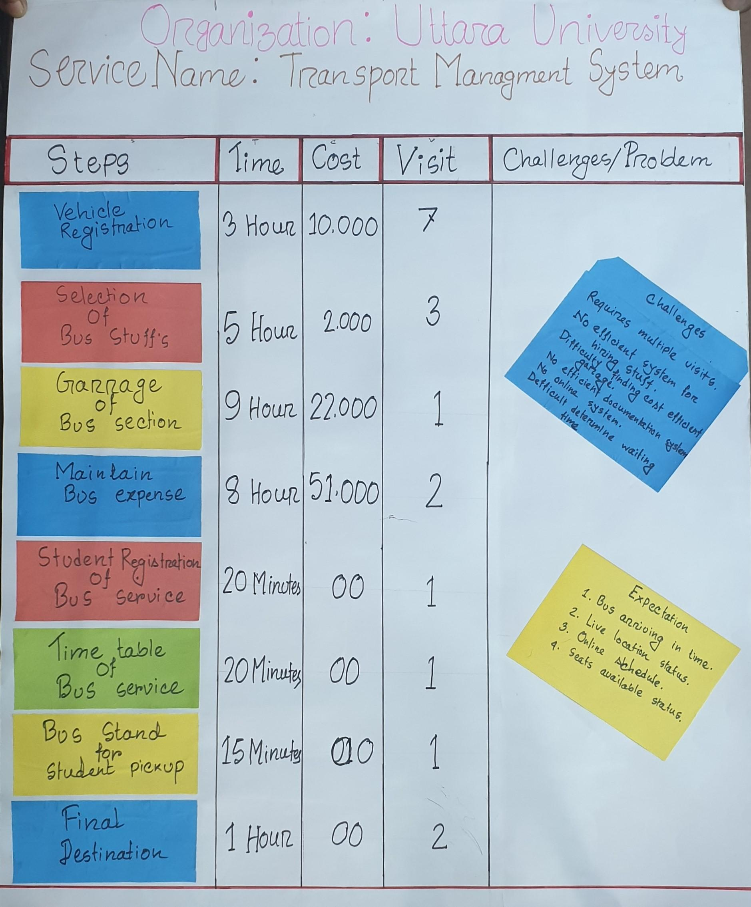

#### 

#### Existing Services Process Analysis (ESPA)

| Existing Service Process Analysis | | | | | | | | | |
| --- | --- | --- | --- | --- | --- | --- | --- | --- | --- |
| Organization's Name | | Uttara University | | | | | | | |
| Service Name | | Transport Management System | | | | | | | |
| SL | Steps | Action | Document Action (receive, dispatch, processed, Saved, Attached, Check ) | Actor | Media/Medium | Time | Citizen Cost (BDT) | Citizen Visit | Challenges/Problems |
| 1 | Vehicle's Registration | Photocopy of Certificates | application form | Assistant | Manual | 1 Hour | 10000 | 4 | Requires multiple visits |
|  |  | Payments Slip Submit | Money Receipt | Assistant | Manual | 2 Hour |  | 3 |  |
| 2 | Route Permit of Bus Service | Get Number Plate | Register | Assistant | Manual | 1 Hour |  | 2 |  |
|  |  | Fitness & Tax Submit | Documents | Assistant | Manual | 2 Hour |  | 3 |  |
|  |  | Driving License Issue | Documents | Assistant | Manual | 5 Hour |  | 2 |  |
| 2 | Selection of Bus Stuff's | Circular Published | Leaflets | Peon | Manual | 2 Hours | 2000 | 2 | No efficient system for hiring stuff |
|  |  | Interviewing Stuff for Bus | Document Review | Assistant | Manual | 3 Hours |  | 1 |  |
| 3 | Garage of Bus Section | Finding a place for garage |  | Peon | Both | 4 Hours | 2000 | 1 | Difficulty in finding cost efficient garage |
|  |  | Renting garage for Bus | Attached | Assistant | Manual | 5 Hours | 20000 | 0 |  |
| 4 | Maintain Bus expense | Buying fuel for Bus | Receipt for buying oil | assistant | Manual | 4 Hours | 50000 | 0 | No efficient documentation system |
|  |  | Bus Repairing Cost | Receipt for new materials | Chairman | Manual | 3 Hours | 0 | 0 |  |
|  |  | Made Students bus service Form | Registration system | Assistant | Manual | 1 Hours | 1000 | 2 |  |
| 5 | Student Registration of Bus Service | Registration form Transmit | Document | Students | Manual | 20 Minutes | 0 | 1 | No online system |
|  |  |  |  |  |  |  |  |  |  |
| 6 | Time Table of Bus Service | Making Notice of Bus Time table | Document | Assistant | Manual | 10 Minutes | 0 | 1 |  |
|  |  | Publish Bus Table Notice | Document | Peon | Manual | 10 Minutes |  |  |  |
| 7 | Bus Stand for Students Pickup | pick up Students from Bus Stand | Receive | Helper | Manual | 5 Minutes | 0 | 1 | Difficult to determine waiting time |
|  |  | Call Students Attendance | Document | Helper | Manual | 10 Minutes | 0 | 0 |  |
| 8 | Final Destination | Bus Arrived at University |  | Bus Stuff | Manual | 0 | 0 | 1 |  |
|  |  | Bus Arrived in Garage |  | Bus Stuff | Manual | 1 Hour | 0 | 1 |  |

**Problems and Challenges:**

Passenger:

The passenger faces many problems such as:

* No location status.
* No emergency road.
* There is no way to give feedback.

Admin and stuffs:

* No efficient system for hiring stuff.
* Difficulty in finding a cost efficient garage.
* Sometimes facing inadequate technical support, delay of taking decisions and lack of timely report.
* No way to get feedback from passengers.

## Proposed Transport Management System (To-Be)

### Transport Management System Objectives

Objective of this initiative is to design, develop and implement a passenger centric transport Platform for all passengersof Uttara University to ensure accountability & satisfactory service.

#### Transport

* The passenger objective is, to have online information service transport platform, notification, email, primary tools and technique to get all services information through web & mobile apps.
* Reduced Time, Cost and Visit.
* Track own applications.

#### Admin and stuff

* Provide tools and technique for managing all Process in an organized manner.
* To ensure timely services in a transparent manner.
* To automate all official work related.
* Eliminate clerical activities in the process

#### Transport Management System Observer

* To monitor the activities of transport and all the passengers and stuff.

### Transport Management System Scope

#### Passenger

* From this Platform, passengers will be able to view all types of available services as well as service wise prerequisite checklist.
* Service Recipients will apply online for all types of services without harassment and unnecessary delay.
* Through this system, Service Recipients will be able to submit Appeals, queries, suggestions, opinions or complains easily & system will notify of mitigation status & actions taken.
* Service Recipients get notification on latest status of his/her application. They can also log in to the system to know of next step, authority etc.

#### Admin and stuff

* System will prepare all required documents in defined format which will reduce significant clerical job hour of Service Providers.
* When implemented & integrated with other system of the university, information will traverse in the organization seamlessly which will increase efficiency & accuracy.
* Through this online system, customers will easily communicate with each other & be able to share & view calendar to set schedule efficiently
* Through this system, admins will easily communicate with customer, which will ensure better, efficient & effective service
* Seamless integration with payment gateway will eliminate all hassles of lengthy banking channels.
* Archiving & searching facilities will make searching easy which will ensure better decision making

#### Transport Management System Observer

* With Service monitoring dashboards transport management system Monitoring authority will be able to make decisions efficiently
* Approver authority can act of application with mobile app from anywhere, without attending office.

## Transport Management Functional Requirements

### Solution Architecture

Solution architecture is expected to define and describe architecture of the proposed Transport Management Solution. The solution architecture should assist in the translation of the service to Transport Management System transformation requirements into a solution vision, high-level operations and/or ICT application specifications and a portfolio of implementation scope. The expected architecture of a solution, where the solution is a Transport Management System that should offers a coherent set of functionalities to its environment. As such, it should concerns those properties of a solution that are necessary and should be sufficient to meet its essential requirements. The vendor shall propose comprehensive solution architecture on Transport Management System platform which may cover the following items in their descriptive and diagrammatic presentation

* Goals/Results
* Customer advantages
* Admin and stuff advantages
* Transport Management System Observers (Service Administration and Performance Monitor)
* System federation (Systems to be integrated)
* Application

### Transport Management System Functions and Features

To reach the ultimate objective of this Digital Service development and implementation of the system may have the following Components with necessary Modules, features and functionalities. However, the selected vendor must perform a detailed requirement study and system analysis and prepare the necessary deliverable.

#### Module and Digital Feature List

Vehicle Management

* Input all Categories Vehicle
* Vehicle's current status and documents
* Assign Staff into a Vehicle
* Fuel cost and status management
* Vehicle Maintenance

Passenger & Office Staff Management

* POS passenger ID into vehicle POS
* Students & Office stuff Database

Road Management

* Input road with distance
* Input Bus Stand with Schedule
* Emergency Road information

Report and FAQ Management

* Service Rating by Passenger
* Feedback and recommendation
* Report & status of Service
* FAQ

#### Transport Management Module diagram

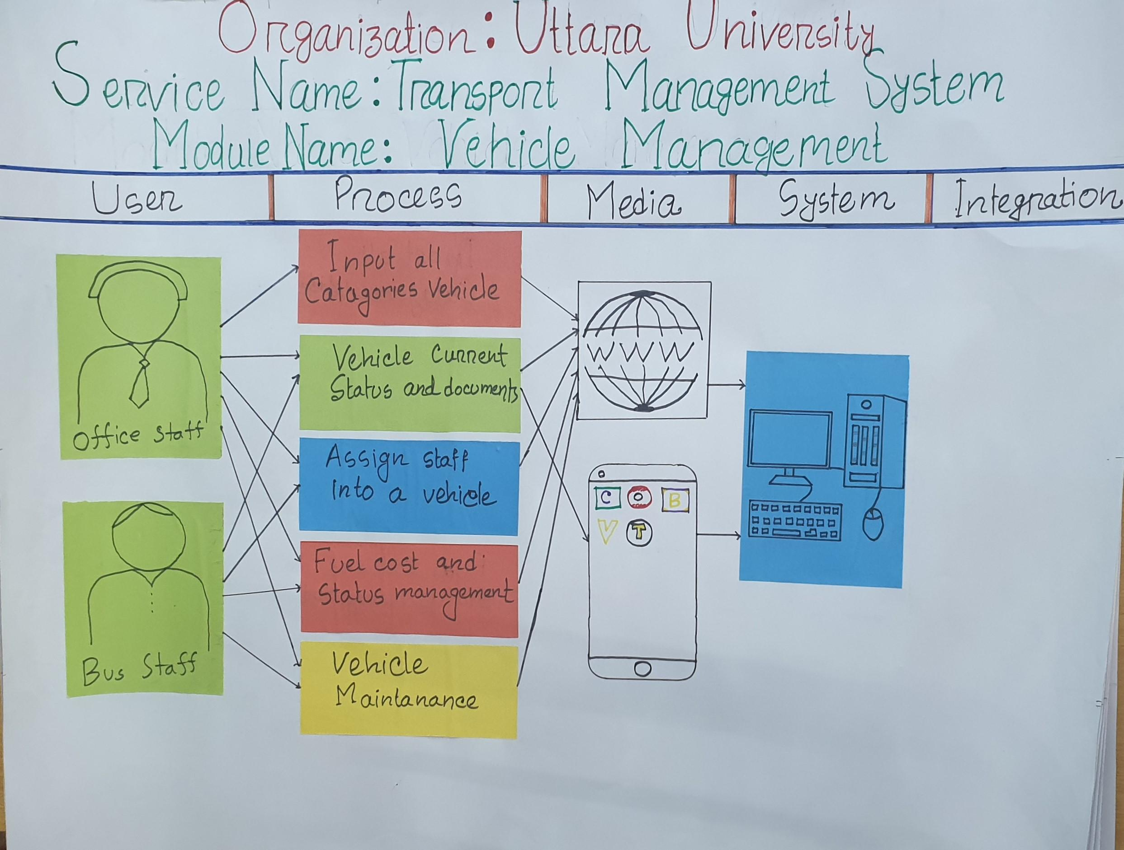

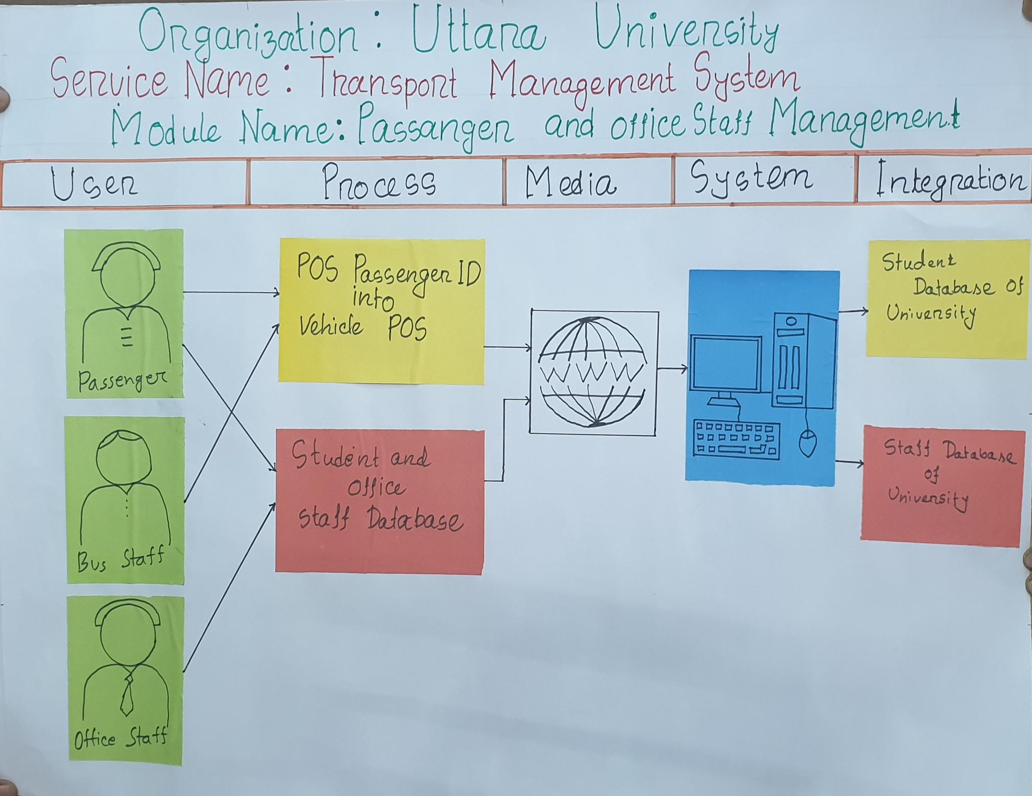

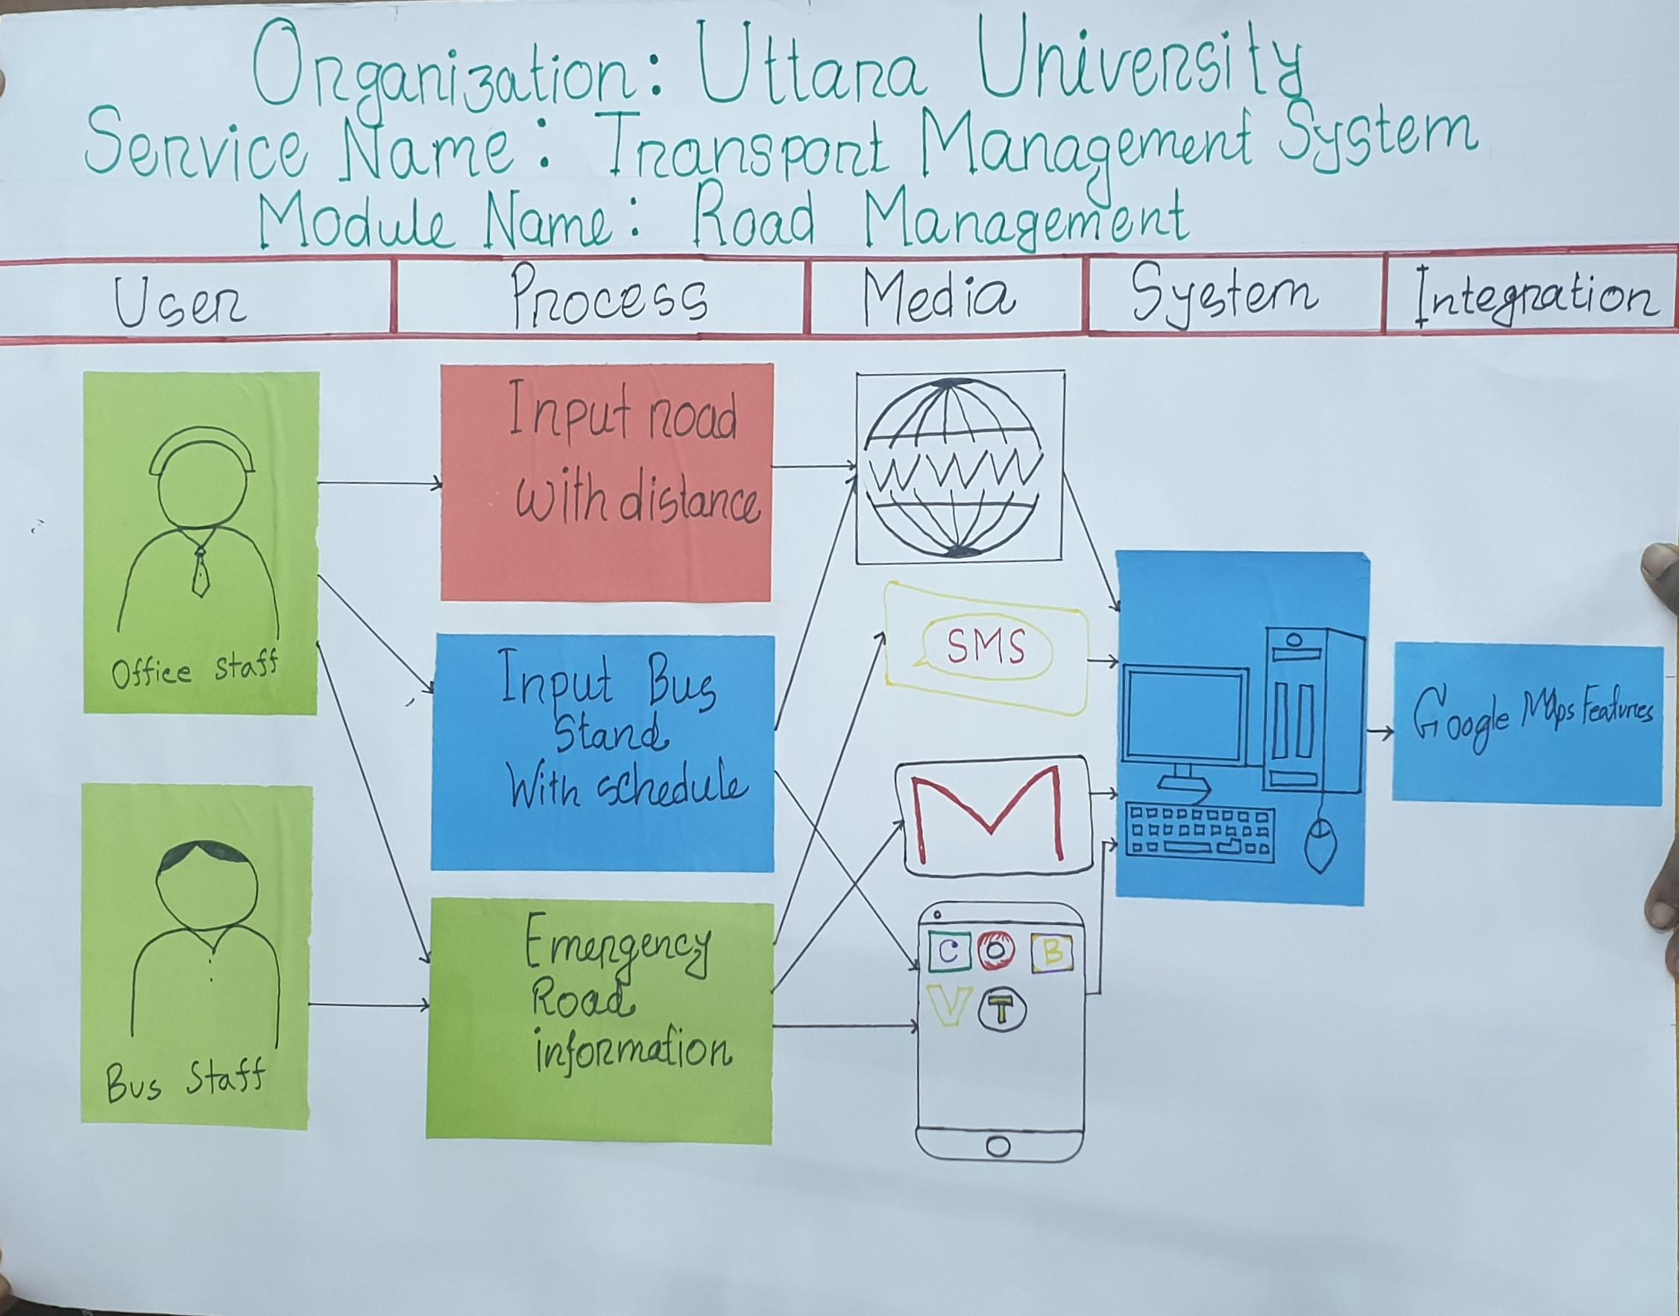

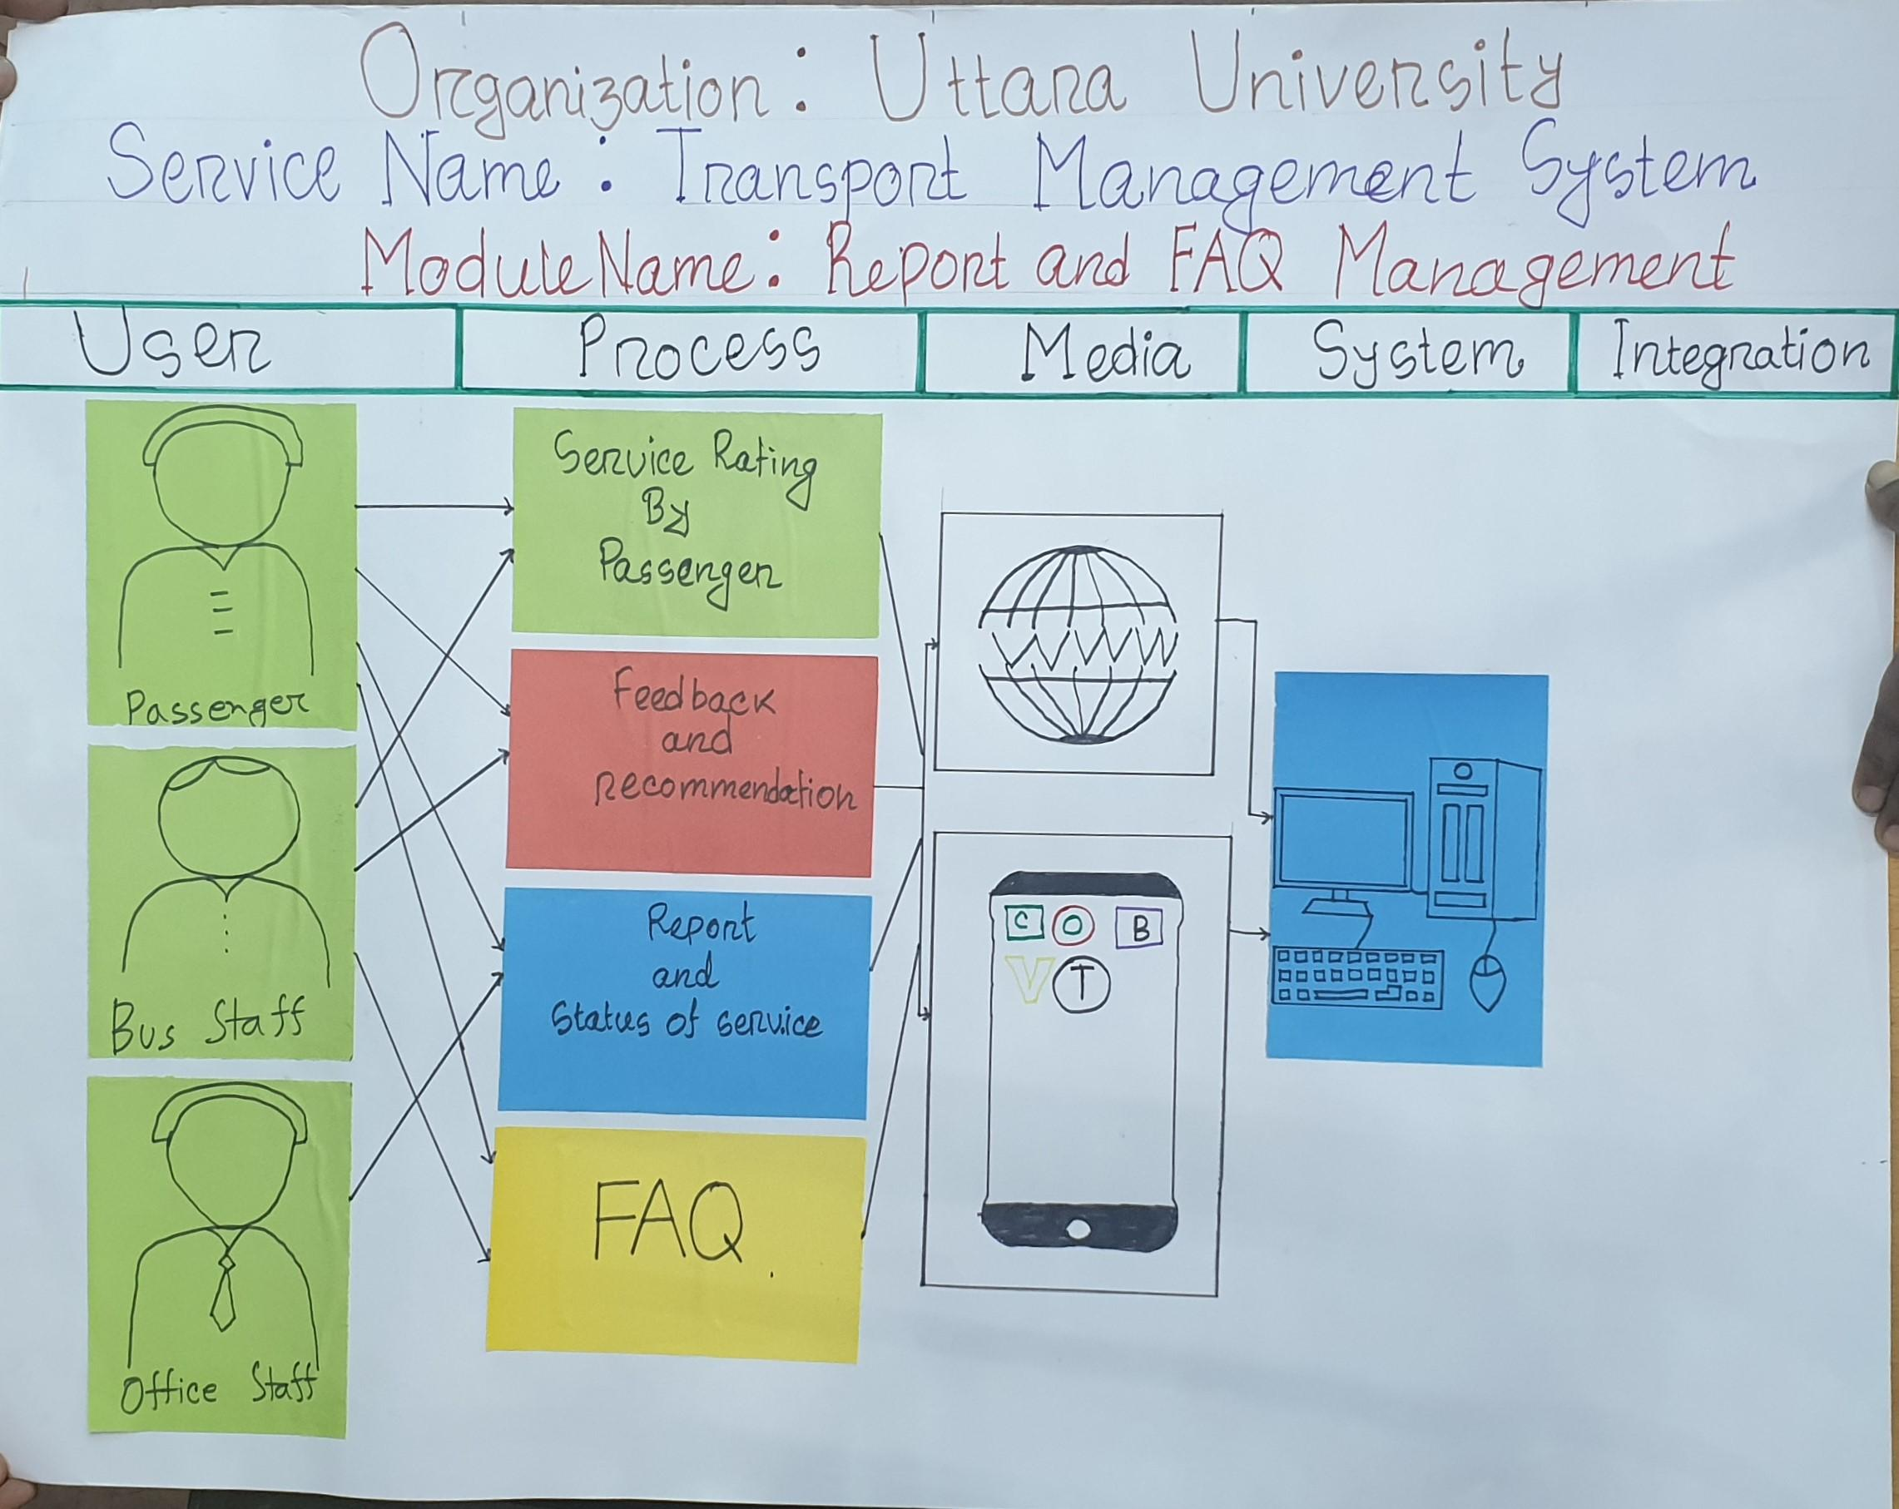

#### Component: Training & e-Learning Management System

| Digital Service Functional Scope Analysis | | | | | |
| --- | --- | --- | --- | --- | --- |
| Organization Name: Uttara University | | | | | |
| Component Name: Transport Management System | | | | | |
| e-Module | e-Feature | User | e-Feature Description | Media | Intigration |
| Vehicle Management | Input all Categories Vehicle | Office Staff | Office stuff will put the description of all the vehicles in this feature. The description will include the purchase price of each vehicle, delivery date of purchased vehicles, signatures of buyers, sellers and notary public. Office stuff can update the information whenever needed. | Web |  |
|  | Vehicle's current status and documents | Bus Staff, Office Staff | This feature will show the current status of vehicles. Documents that will be included are Registration paper/Smart Card, Tax token, Insurance, Driving license, fitness of vehicles, route permit. All the expiration dates will also be shown here. | Web, Apps |  |
|  | Assign Staff into a Vehicle | Bus Staff, Office Staff | This feature will help office stuffs to hire new bus stuffs. The information regarding interviewing and hiring process will be stored here. Documents will include driver license, CV, reference of applicants. | Web |  |
|  | Fuel cost and status management | Bus Staff, Office Staff | In this feature bus stuff will put daily fuel cost of each vehicle with proper documentation such as receipt of bought fuel. Office stuff will put the amount of money given to the bus stuff for fuel cost here. | Web |  |
|  | Vehicle Maintenance | Bus Staff, Office Staff | Bus stuff will put the name and cost of vehicle parts needed for repairing or replacing here. Office stuff will include the amount of money given to bus stuff for repairing or replacement. | Web |  |
| Passenger & Office Staff Management | POS passenger ID into vehicle POS | Passenger , Bus Staff | This feature will ensure that the passengers and bus staff are identified by the POS machine. Daily attendance will be updated here after being identified. | Web | Students Database of University |
|  | Students & Office stuff Database | Passenger , Office Staff | This feature will include profile database of all the passengers and office staffs. Database will have name, NID& profile picture of the passengers and office staffs | Web | Staff Database of University |
| Road Management | Input road with distance | Office Staff | Office staff will set the route of bus transit and distance of location | Web |  |
|  | Input Bus Stand with Schedule | Office Staff | Office staff will create schedule that will have the time of arrival & location of bus stand | Web, Apps | Google Maps Features |
|  | Emergency Road information | Bus Staff , Office Staff | Bus staff can inform to office staff when bus needs emergency road | SMS, email, Apps |  |
| Report and FAQ Management | Service Rating by Passenger | Passenger , Bus Staff | Passenger can rate the service with this feature. Rating will be a five star system. The passenger can rate the service from 1 start to 5 star. | Web, Apps |  |
|  | Feedback and recommendation | Passenger , Bus Staff | Passenger can give feedback about service and recommend anything. | Web, Apps |  |
|  | Report & status of Service | Passenger, Office Staff | Office Staff will update the schedule status of service time when needed. Office staff and passenger can check the schedule anytime using this feature. | Web, Apps |  |
|  | FAQ | Passenger , Bus Staff | Frequently asked questions (FAQ) will be answered in this feature. The passenger can use this feature to know the answers of all the frequently asked questions. | Web, Apps |  |

N.B.: The interested vendor must comply all above mentioned modules and features but not require to limit in this list. Apart from this, the interested vendor should analyzed the other scopes which are relevant to the areas covered above and should propose the best possible and comprehensive ICT solutions in there technical proposal. The ultimate modules and futures of the proposed system will be finalized at the requirement study and analysis phase of SDLC based on client’s actual requirement, acceptance and vendor’s best proposal/solutions relevant to the above mentioned area and scope.

### Users and User Roles

The following table gives a general idea / overview of user types and roles. The vendor shall conduct a more detail analysis of types of user and user roles during System Requirements Specification (SRS).

| Transport Management System | | | | | |
| --- | --- | --- | --- | --- | --- |
|  | | | | | |
| Sl. | Type of Users | No. of Users | No. Of Office/Location | User Title | User Major Role | |
| 1 | Office Staff | 7 | 1 | * Staff | * Vehicle Management * Road Management * Report & FAQ Management | |
| 2 | Bus Staff | 14 | 1 | * Driver * Helper | * Vehicle Current Status and Documentation * Fuel cost and status management * Feedback and recommendation * FAQ | |
| 3 | Passenger | 350 | 1 | * Students * Teacher | * POS passenger ID into vehicle POS * Students & Office stuff Database * Service Rating * FAQ | |

Vendor should submit a comprehensive plan and approach covering different types of users and their roles providing accessibility, privacy, confidentiality and transparency based on the given statics. Also have to mention the user friendliness login system.

**Special note: Who has the e-Filing integration option:**

If the proposed Transport Management System application needs to integrate and interoperable with Uttara University prescribed e-Filing system then vendor should have design the seamless, smooth and user friendly single login system.

#### Use Case Diagram

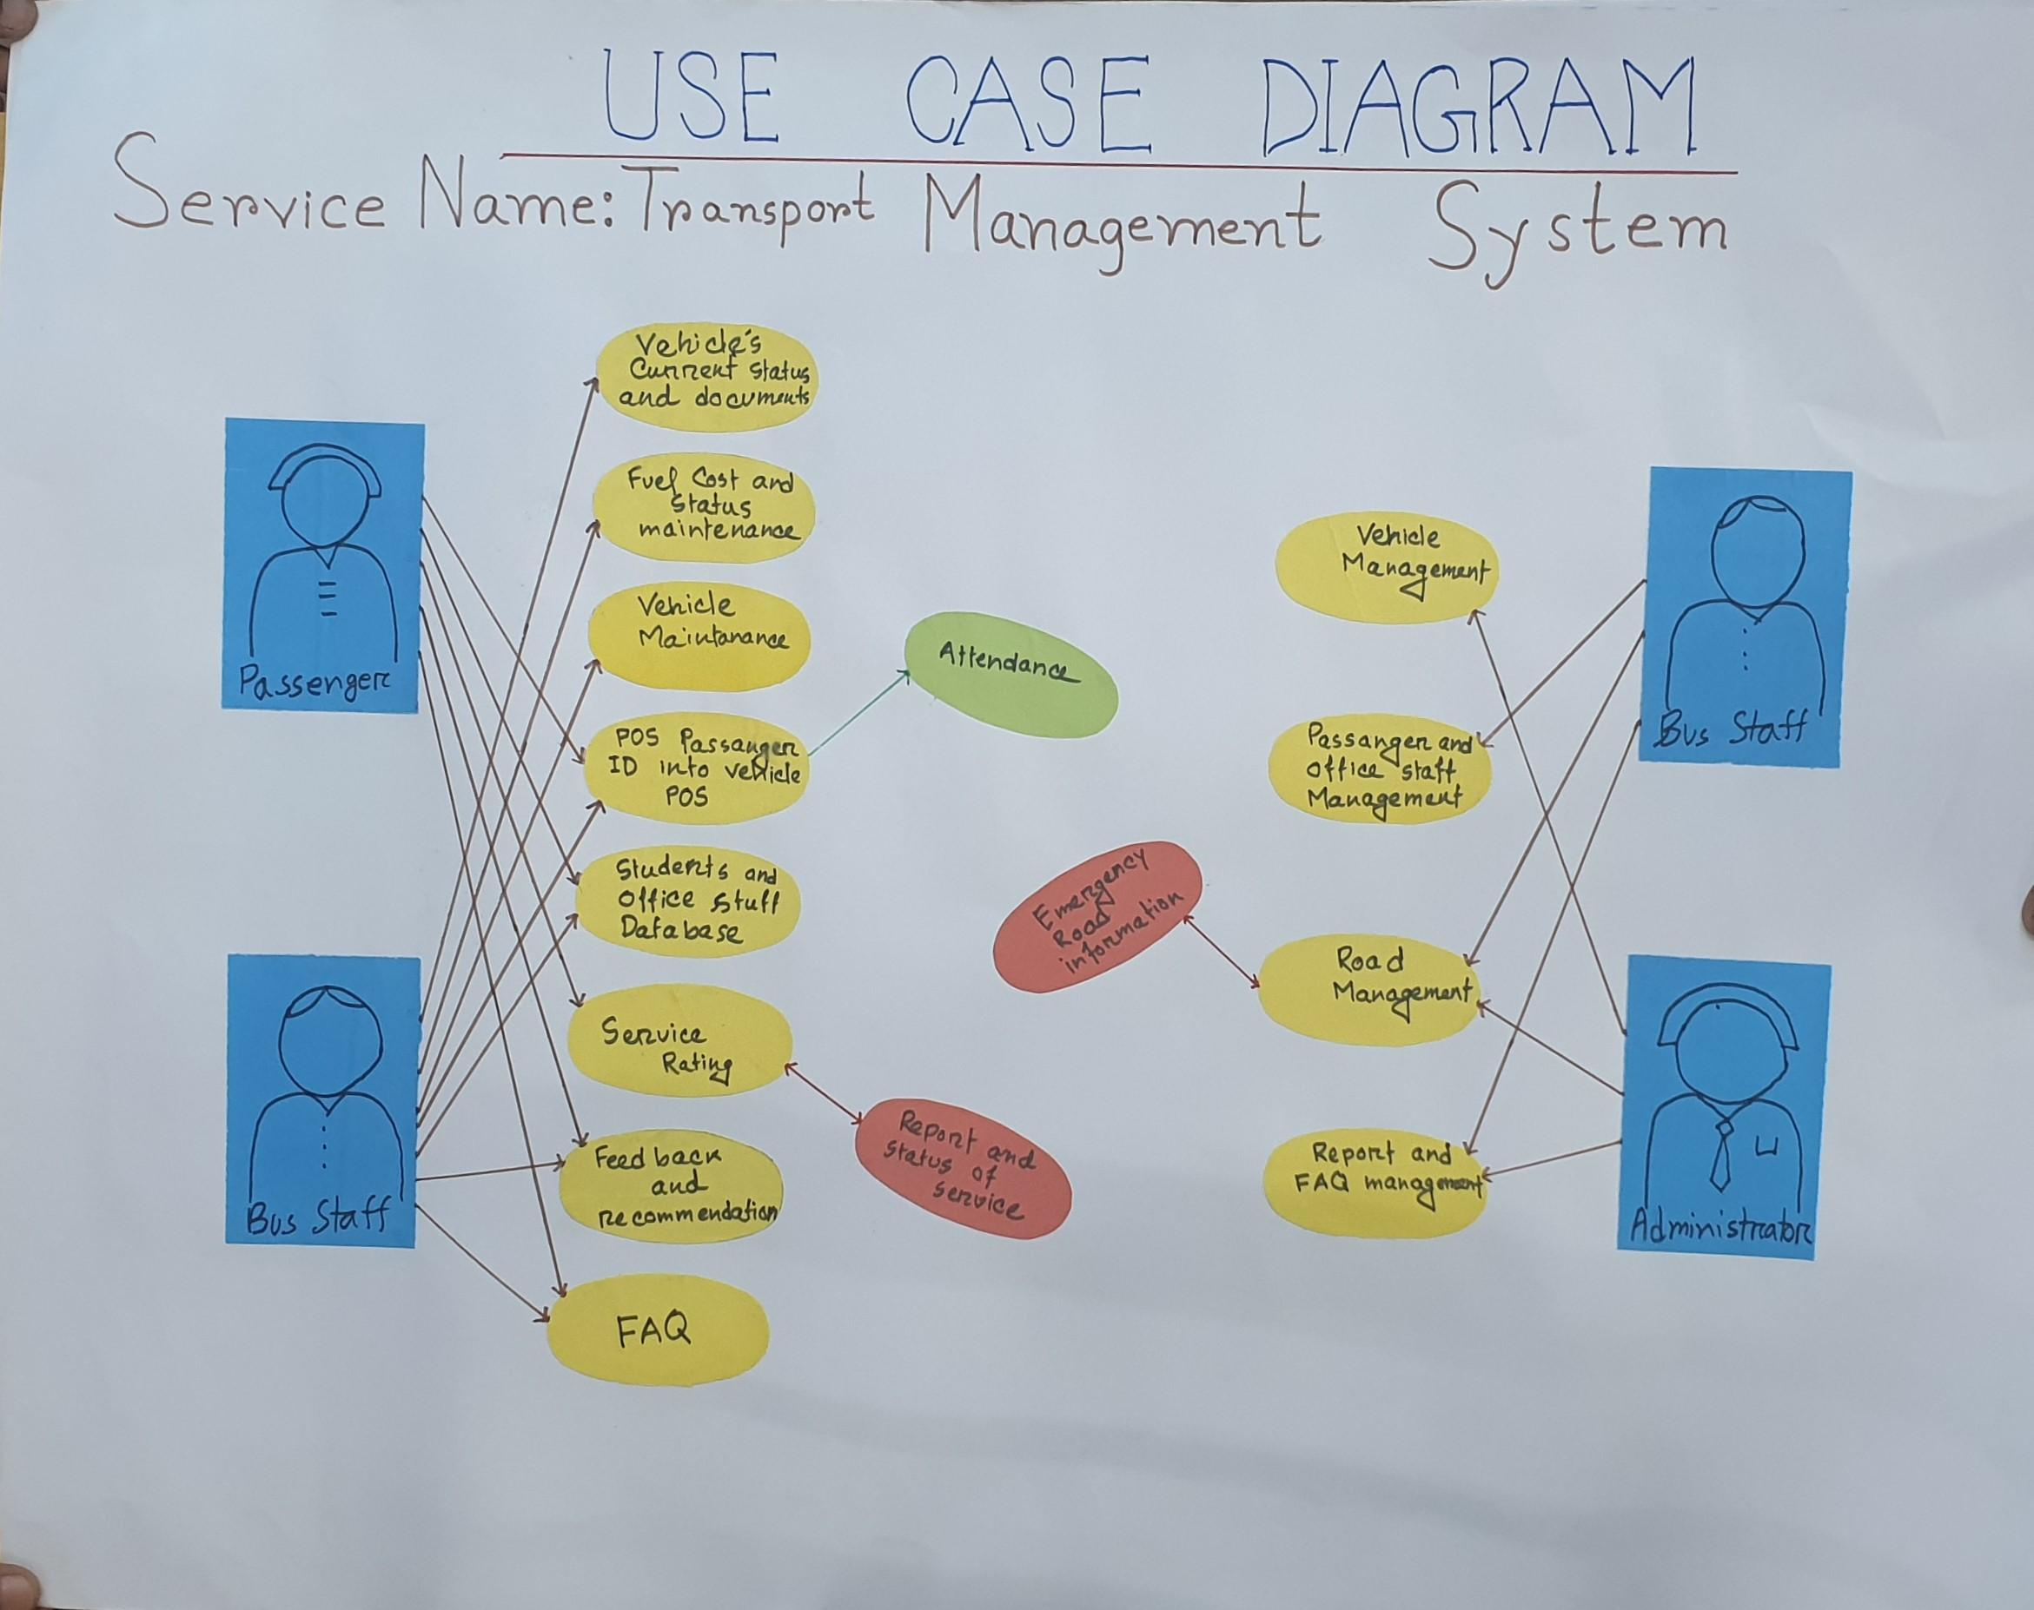

#### Activity Diagram

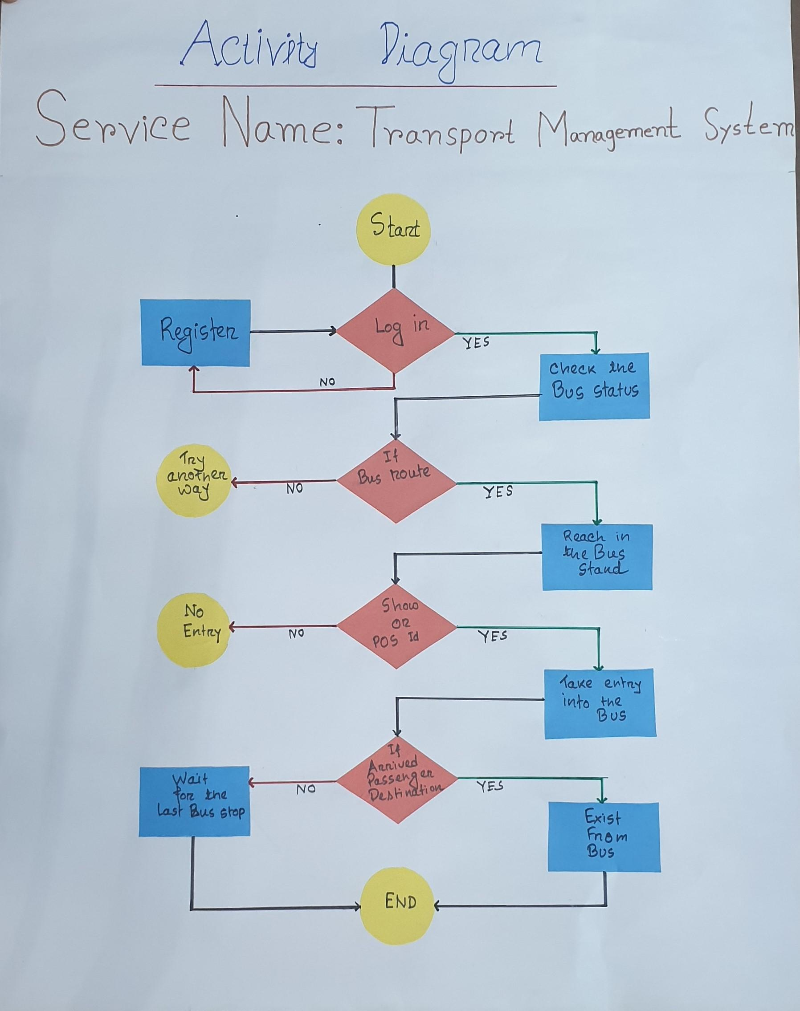

### Security and Privacy Requirements

The vendor should submit an extensive and complete security and privacy plan for this Transport Management System application considering the following issues

* Project technical scope
* Functional and nonfunctional requirements and ultimate objectives
* Concerned service provider organization’s operational environments and capacity
* User roles - Accessibility, Authorization and Accountability
* Importance of data management
* Technologies to be used for development & run
* Hosting
* Client and service side
* Overall standard application security requirements.

Apart from these, the vendor should keep in account the following considerations also as well as vendor should provide a checklist based on system and hosting security plan (i.e. fraud, hacking, money laundering etc.) & have to provide the test report of that checklist.

### Integration Requirements

As Uttara University system or Transport Management System application, integration with the required and other prescribed national system is very important and essential. Only by proper integration making interoperable, a Transport Management System application can drive the ultimate citizen benefits with the optimum use of technology from service to Digital Service transformation. Here vendor should come up with an integration plan in their technical proposal considering and understanding the scope of the Digital Service application as per this TOR. The possible integration scopes of this Digital Service application are mentioned below as reference for the vendor.

| **No.** | **System Name** | **Purpose** | **Dependent Organization** |
| --- | --- | --- | --- |
|  | Uttara University | Get the teachers and students information for profile | Uttara University |
|  | NID | Verify Service Recipients Identity | Election Commission |
|  | Google Map Location Feature | Document Approval maintaining the Organogram. | Google |
|  | Payment Gateway | Cash loan collection & disbursement | Cash, Bank Check, Credit Card. |

### Hosting Requirements

Bangladesh Government is providing an extensive and standard hosting facility for all types of government organization applications and software that is named as National Data Center under Bangladesh computer council (BCC). It may be mentioned here that the vendor developed application will be hosted in Uttara University provided data center. Therefore, at this stage, vendor is requested to submit a preliminary hosting plan for this Digital Service application considering the issues mentioned below-

* Hosting requirement /environment (hardware, servers, network, security, storage, traffic, firewall, bandwidth etc.)
* Hosting architecture
* Data growth and scalability plan
* User handling/load balancing mechanism
* Licensing issues
* Scheduled backup & restore requirements
* Disaster recovery requirements
* Monitoring tools requirements

## Digital Service Non-Functional Requirements

### Application Compliance Requirements

#### Web Application

* The application which is a web based solution, has to be hosted in a centralized Web-server
* The application should be developed following Service Oriented Architecture (SOA)
* Application should support MVC framework.
* Considering the operating/client environment at different level of this application, it should be developed in such a way so that it requires low bandwidth to run.
* The web-based application should support cross browser platforms (popular web-browsers such Mozilla Firefox, Opera, Chrome, Internet Explorer, Safari etc.)
* Should have ability to seamless integration with future module/components/applications
* Application should be lightweight and rich client-side scripting
* UI should be developed based on the analysis of UX.
* Any web interface of this application should be fully responsive

#### Mobile Application Requirements

* The mobile application version of the system should be developed for Android and iOS.
* The mobile app should have capability of displaying system notifications
* Functionality for registration options for service recipients
* App should enable compact view of services for service recipients.
* There should be an option to auto synchronization with the central database with apps local database on the availability of the Internet connectivity.

### Sizing, Performance and Scalability Requirements

* The system shall be capable of handling online functionalities for a database of at least 12,000 service recipients and in terms of service provider 10 and 50 System Users.
* The system processing shall be scalable to support the **volume estimates for a period of 10 years at a 20% annual growth rate**.
* The system shall be designed to handle estimated8000/10000simultaneous connection (online users) when it is ultimately rolled out.
* The vendor must conduct an extensive load testing task taking above factors into consideration and submit a load testing results.
* The database architecture should be such that the system is available to user 24x7x365 days a year without any unapproved downtime.
* Page load time, login response-time, on-click load time for the web application should be less than 3 seconds while this is accessed over the intranet.
* Average transaction response time, on-submit response-time, or any other database access/ search time should be less than 5 seconds when the system solution is accessed over the intranet.
* Considering the network infrastructure challenges in Bangladesh, the solution must support low bandwidth conditions for the services defined in the functional requirements.
* In case of mobile application also, this should support very low bandwidth even in 2G network provided internet bandwidth.
* The proposed solution should be highly scalable to accommodate current and future requirements within the scope of the scope mentioned in the TOR
* Analyze the requirements whether both horizontal scaling (scale-up) and vertical scaling (scale-up) will be required for this Digital Service application or not?
* The Digital Service application should be provided with appropriate caching mechanism to handle very high-traffic scalability
* The vendor may propose here other relevant measures for the Digital Service application scalability.

### Business Continuity

Business Continuity plan will play a very important role by creating the systems of prevention and recovery to deal with potential threats and risk of the Digital Service operation. Vendor is requested to propose a Business Continuity Plan for this Digital Service application. Regarding business continuity you may take in account the followings issues if applicable or suitable for this Digital Service Application

* All standard backup facilities should be supported by the system which can be started with disk-based backup facility; gradually moving to Storage Area Network (SAN) based backup system.
* Data and the Operating system core component will be separated. A ghost image of the Operating system will always be available in case of rebuilding the server. All data can be restored in the data drive once the Operating System is restored.
* System can also have an automated Backup mechanism by which users can schedule the backups and the system will take the backups without manual intervention.
* System must check for the media and generate a report on backup with date time and details of backup.
* If a restoration fails for any reason, the system should prompt with proper error messages and suggest what has to be done to rectify the situation via on-screen, logs, email and text messages.
* System should maintain an automated recovery system and all versions of backup will be maintained. At any given point in time, the versions and incremental backup details can be retrieved from the system.
* The system may be hosted in virtual servers or containers. A restore of a virtual server/container is much easier and faster compared to a single host server.

### Interoperability and Data Exchange

The selected vendor must develop this Digital Service system following all the standards and protocols of interoperability, integration and data exchange with other systems. It is expected that the system will be based on open architecture and will be fully interoperable with the current and future systems.

The following are the key expectations on interoperability requirements:

1. The system should be designed for interoperability using industry standard protocols.
2. System must expose data by Advanced Message Queuing Protocol and REST via TLS
3. All imported data must undergo data validation to ensure full integrity.
4. Data exchange within the system at different levels via the internet shall be encrypted.
5. The system should have functionality to exchange data with other own systems or external institute systems.
6. The system shall have functionality to export/import files based on the standard template defined through web services and/or API

Full API documentation must be provided so that third party integrators can integrate their system with this system.

### System Audit

This Digital Service system will maintain an audit trail of any changes or updates made in any information that are considered as vital and should maintain the audit log with information such as

* Log the users who are accessing the system
* Log the parts of the application that are being accessed
* Log the fields that are being modified
* Log the results of these modifications
* Log attempted breaches of access
* Log attempted breaches of modification rights
* Timestamp.

Ensure an audit trail is kept for all transactions and all audit transactions logged are kept on the trail file or trail database from where system can generate different audit reports as and when required.

### UI/UX.

The vendor must propose a UI/ UX plan containing UI designing method and tools, prototype or Mockup design (if applicable) , UI review method , process for study and analyze UX , collaboration of basic web and mobile UX issues and expected result and outcome of UX, finalizing the UI/UX design. Apart from this, the vendor should consider the following issues as requirement at the time of UI/UX plan.

* The system interfaces should be highly user friendly, easy to navigate and ensure fast loading.
* The UI shall design by using well-established, supported and lightweight UI framework so that it follows widely used industry flow patterns
* UI shall be easily configurable if any changes are needed
* Menu, content and navigation shall be based on the user entitlements, roles and permissions.

### Language Support

The Digital Service system should support multilingual option i.e. Bangla and English for both the Web version and Mobile Apps. All the user interfaces will be able to display and input controls can take input both in Bangla and English. System/App users can choose and set his/her preferred language in profile setting for the system interfaces. The system should support Unicode for the Bangla Language.

### Accessibility

Vendor must develop this Digital Service application ensuring access for the citizen (Service Recipients) with disabilities in different standard accessible formats. Digital Service application should be developed in “universal design” and “assistive technologies”. Accepting and facilitating the use of sign languages, augmentative and alternative inputs and all other accessible means, modes and formats for inputs and outputs as per their choice by “Service Recipients” with disabilities; all Digital Service features (Web application or Mobile Application) should be usable with the help of screen reading software by the service recipients with disability

### Coding Conventions

The vendor must follow the standard coding styles to produce high-quality code for further uses of the code in terms of reusability, refactoring, task automation, language factors etc. The vendor should submit a standard coding convention approach, which may include different conventions like commenting, indent style, naming etc. following the best coding practices.

### Documentation

Detail and proper documentation of such ICT based project like Digital Service application development and implementation for Uttara University is very vital and essential. Documentation is required for any such project as reference, knowledge transfer, analysis of development and implementation history, baseline information for any modification or change, guidance etc. In this issue, Vender should shows highest-level of professionalism for delivering the standard documentation approach at each phase of Digital Service development and implementation project. Vendor should include an extensive documentation plan of this project in their technical proposal, which may cover the followings

* Documents titles phase or activity wise
* Purpose of document
* About the format of documents (if possible only index or fields)
* Type of expert and skilled resource will be used for documentation
* Document priority and dependency
* Time requirement for preparation (If applicable)

### Tools and Technologies to be used

* Vendor is recommended to choose the appropriate tools and technologies to be used for the development and implementation of the Digital Service application. The selected vendor has to consult with Uttara University and Transport Management System to finalize the tools, technologies, framework and platform with the approval of same authorities consent.
* The main components of the software will be web based application. It should be run in Windows/Linux/OS x operating system at user end and should be compatible to all major browsers such as – Internet Explorer, Firefox, Google Chrome, Opera etc.
* The System UI should be compatible with Tab & Smart Phone browsers and in case of Mobile Apps should be support both Android and IOS

Understanding the details scope of this project, vendor is requested to submit a comprehensive plan in their technical proposal following the table format mentioned below

| **Issues/Phases/Purpose** | **Used Technology/ Tools** | **Justification for use** | **Alternative Tool/ Technology** |
| --- | --- | --- | --- |
| **Project Management** |  |  |  |
| **Version Control** |  |  |  |
| **System Requirement Analysis** |  |  |  |
| **System Design** |  |  |  |
| **Development (Client end)** |  |  |  |
| **Development (Server end)** |  |  |  |
| **API/Web services** |  |  |  |
| **Apps** |  |  |  |
| **Testing** |  |  |  |
| **Integration** |  |  |  |
| **Hosting & Deployment** |  |  |  |
| **Documentation** |  |  |  |
| **QA** |  |  |  |
| **Helpdesk/Support** |  |  |  |
| **Reporting** |  |  |  |
| **Communication** |  |  |  |

### Quality Attributes and Assurance

* The Quality attributes and Assurance plan will describe the standards, processes and procedures in this Digital Service application development life cycle which will be used to support the consistent delivery of high-quality, professional standard Digital Service application and services provided in the support of an automated environment. The quality assurance process will be concerned with establishing the authority of the QA function, quality assurance standards, procedures, policies, and monitoring, and evaluation processes to determine quality in relation to established standards. Quality assurance activities will concentrate on the prevention of problems through the continuous improvement of processes.
* In order to provide high quality products and services, each support team will adhere to processes, procedures and standards. Quality Assurance (QA) is a process used to monitor and evaluate the adherence to processes, procedures, and standards to determine potential product and service quality. It will involve reviewing and auditing the products and activities to verify that they comply with the applicable procedures and standards, and will assure the appropriate visibility for the results of the reviews and audits.
* The vendor is requested to provide an extensive Quality Assurance plan with measurable attributes for each phases of this Digital Service development life cycle in their technical proposal.

### Copyright

* Transport Management System shall be entitled to all proprietary rights including but not limited to patents, copyrights and trademarks, with regard to many Vendor.
* All kinds of source code including code documentation and other approved documents (all versions trail, products , developed applications, documents and all kinds of deliverables which bear a direct relation to or is made in consequence of the services provided by the vendor under this scope of this TOR.
* At the request of the Transport Management System, the vendor shall assist in securing such property rights and transferring them in compliance with the requirement of the applicable law. After the completion of the project such rights will be handed over to the Transport Management System that will be produced at the time of entire system development and implementation life cycle under the scope of this TOR will be owned by of Transport Management System.
* The vendor should properly deliver all the entire approved source codes and other deliverables to the Transport Management System. The vendor cannot claim any royalty or authority of any sort in case of replicating the source code or database or any other deliverables under this TOR for any future use that Transport Management System and the Government of Bangladesh may see fit.
* Any studies, documents, reports, graphics or other material prepared by the vendor for this project under this TOR shall belong to and remain the property of Transport Management System.

## Scope of Work

### Development and Implementation Methodology

Development methodology i.e. SDLC plays a very important role to clear the ultimate project objectives precisely, to stable the project requirements, to monitor the progress with measurable deliverables and managing the entire project efficiently. Here the vendor is requested to propose and submit a best possible suited SDLC approach for this project considering the project scopes, requirements of e-Service, objectives, organizational environmental factors and behavior, project timeline, ultimate deliverables and various resources to be used.

### System Requirement Analysis

Requirements finalization will be a very important milestone of vendor’s proposed development methodology. It is expected that, the selected vendor will carry out detailed requirement study and analysis on the each and every scope of Digital Service that mentioned in the TOR. Under this scope of work, the selected vendor has to analyze the detail functions, processes, documents, actors, sites and infrastructure of the relevant prevailing system precisely of the concerned organization. At this phase, vendor’s ultimate objective will be finalization of the Digital Service requirements in details under the scope of TOR and approval of the concern organizational authority. Here vendor is requested to propose and submit a system requirement analysis plan which should cover the scope of work at this phase, relevant activities to be performed, timeline, deliverables to be produced, dependencies and resources to be used.

### System Design

At this phase, the detail functional scope defining and designing as per the standard of software engineering approach for the proposed Digital Service system tasks are being performed. This is very vital and important phase of any SDLC. Considering the ultimate development and implementation scope, the proposed system design should be robust, scalable, user friendly and interoperable enough.

At this system-designing phase, vendor may performs following designing related task and will produce various standard System Designing Documents (SDD):

* Identifying module, components, tasks, I/O and functional features
* Specifying technical and functional requirements
* User Interface design
* Description of UI and requirements
* Preparing the use cases
* Defining Integration and interoperability scope
* Designing system architecture
* Determine process and data flow
* Database design
* API design
* Finalizing tools, technologies and frameworks to be used etc.

Here vendor is requested to cover details system designing plan in their technical proposal, which may include relevant activities, approaches, methods, documentations and deliverables.

### Development

At this stage, vendor must take prior acceptance or approval from the concerned authority on tools, technologies and framework that will be used for the development of the Digital Service application. Based on approved SRS and SDD, vendor will prepare a comprehensive development plan for the Digital Service Application which should include a schedule consisting development item wise start date, test date, review date, completion date etc. At the development stage, vendor must follow the standard code convention, code level documentations, header of each file, algorithms, interfaces, code compression and APIs should be supplied with proper description and documentations. All kinds of standard testing tasks that are required to be performed at the development phase should be mentioned in the plan. Considering the scope mentioned in the TOR for this Digital Service application, vendor is requested to include a preliminary development plan (standard approach) in their technical proposal.

### Integration

Considering the above mentioned Integration requirements and scopes for this Digital Service application, vendor must include a phase in their proposed development and implementation methodology approach. At this stage, the vendor will perform all necessary tasks regarding integration to make the Digital Service application interoperable.

### Testing

The vendor must propose a testing plan for this Digital Service application starting from development to deployment. This testing plan should cover all the standard suitable testing approaches for this Digital Service application which may include phase wise testing activities like test scripting, test cases, testing tools, testing process, test log, result and report formats i.e. expected test deliverables based on the application development requirements. The vendor should submit testing plan which may include standard test approaches. Some are mentioned below as examples for reference

* Unit Test
* Functional Test
* Installation testing
* Compatibility testing
* Smoke and sanity testing
* Regression testing
* Stress Testing
* Acceptance testing
* Alpha testing
* Beta testing
* Functional vs non-functional testing
* Continuous testing
* Destructive testing
* Software performance testing
* Usability testing
* Accessibility testing
* Security testing

### Hosting

Vendor should submit primary hosting requirements for this application related to hardware, servers, network, security, storage, traffic, firewall, bandwidth etc. i.e. complete hosting infrastructure that will be requires for their developed application hosting considering the implementation scope. Based on their submitted requirements, regarding hosting Transport Management System will provide detail hosting infrastructure, facility and environment.

### User Acceptance Test (UAT)

User Acceptance Test (UAT) is a very vital and essential phase in the Digital Service development lifecycle. At this phase, all types of users must test the developed Digital Service application by themselves and have to provide a detail feedback/ test report. Based on the UAT report, vendor has to update the application accordingly to ensure user satisfaction by making it more user friendly. Here, it is expected that, considering the type of users and their role in the Digital Service application, the vendor must propose a comprehensive UAT plan in their technical proposal which may cover the followings:

* UAT activities to be perform (planning, designing test cases, selection of testing team, Executing test cases and documenting, Bug fixing, sign-off etc.)
* Types of user wise roles and test items distribution
* resource requirement,
* activity wise time requirement
* activity wise test case , test results/ deliverables
* detail user feedback / test reports
* System update plan

### Management and Migration of Legacy Data

Under the process of service to Digital Service transformation, during Digital Service activation or deployment, it may be necessary to move the legacy data of prevailing services. In this case, vendor may require to perform different relevant activities that may include data collection, softcopy conversion, data filter, data cleansing, data verification, data process, data entry, data migration and overall data management. Here, it is expected that, the vendor will propose their detail data management and data migration plan for this Digital Service application considering the estimation of legacy data mentioned below which will be required to migrate into the developed application.

[Hint: A table titled “ Estimation of Legacy Data to be migrated” may place here with the column names like Data About, Description , number of pages/fields , current status, amount of data, dependency]

The plan may cover amount of data to be migrated, activities to be performed, amount of resources to be used, required time for different data migration phases for different activities (data collection, hardcopy to softcopy conversion, data entry, data transformation from soft copy, data filtration, data cleaning, data verification ) etc.

### Deployment and Implementation

This is the phase of SDLC, when the consent is being given to “GO LIVE” of the developed system after completed all kinds of development integration, testing and hosting. This is very crucial and sensitive stage for a University application because at this stage the system becomes public and expose to access towards all levels of users. The Pilot or full scale implementation period starts formally in this stage only. Vendor is requested to propose their deployment and implementation plan covering the major activities to be performed, the deliverables to be provided etc.

### Training and Knowledge Transfer

* The vendor must propose a detail training plan for the users of the Digital Service application.
* The vendor should include necessary training methodology, documentation and training materials support in their training plan
* The training materials may include user manual, administration manual, quick start tutorial, online help, and frequently asked questions
* The training plan must describe the sequencing, time, duration and resources involved in implementation of each of the consultant’s proposed training activities.
* The training plan should contain full course descriptions for all courses that to be carried out for respective users.
* The vendor should develop multimedia training materials for all users. These materials shall be available for viewing and reviewing for all users through a web portal.
* The training instructions should support both English and Bengali language.
* The training activities should cover the training feedback, evaluation and report also.
* The vendor also requested to submit propose their smooth, efficient and effective **Training Plan** and **knowledge transfer plan** here in this technical proposal.

### Duration of the Project and Work Station

The selected vendor will need to work for the above-mentioned scope as per approved project management schedule. The selected vendor must complete Digital Service application development and deployment i.e. development life cycle as per their proposed development methodology within [Number of Days/Months/Years] excluding the maintenance and support service period. .

Now here in their technical proposal vendor is requested to propose detailed timeframe plan which may include:

* Total duration of the Digital Service application development i.e. Digital Service development
* Total duration of the Maintenance and support service at implementation phase
* Proposed SDLC Phase wise and deliverable wise time distribution and duration
* The schedule may cover Activity, Deliverables, Time in Days, Dependencies etc.
* Can be present as table or Gantt chart

### Maintenance and Support Service

The selected vendor has to provide a period of 3 Years maintenance and support service. After the development and deployment phase when the implementation period starts the vendor has to provide maintenance and support service for the 3 Years. Here it is expected that, the vendor must provide a detail maintenance and support service plan in the technical proposal, which may include the followings:

* Support service types and mode of services
* Service desk functionalities
* Configuration management
* Change management
* Service layers for support
* Tools will be used for Support service management
* Communication management and modality
* Release management
* Incident management
* Problem management
* SLA (Service Level Agreement)
* Maintenance and support service related reporting
* Support service types
* Service Log Management

Apart from the above mentioned issues, if vendor thinks any other issue to be included in their plan, it would be considered as added value addition.

### Work Distribution and Team Composition

The vendor is expected to provide work distribution and team composition plan as deemed suited based on this project requirements and milestones and as per their proposed development and implementation methodology approach. The interested applicant (Vendor) should provide a team composition plan in their proposal describing the position, roles, tasks to be assigned, expected man-days of involvement, expected deliverables and required skill and expertise.

However, the vendor shall propose at least the following personnel as minimum requirement:

| SL | Position | No. of Person |
| --- | --- | --- |
|  | Project Manager | 1 |
|  | Software Architect | 1 |
|  | Business Analyst | 1 |
|  | System Analyst | 1 |
|  | Database Administrator (DBA) | 1 |
|  | Sr. Developer/Programmer | 2 |
|  | Developer/Programmer | 2 |
|  | Mobile Apps Developer/Programmer | 1 |
|  | QA Expert | 1 |
|  | Interoperability Expert | 1 |
|  | System Administrator | 1 |
|  | Technical Document Expert | 1 |
|  | UI Designer | 1 |
|  | UX Expert | 1 |
|  | Training Expert | 1 |
|  | Totals | 17 |

**For Maintenance Service & Support:**

| Sl. | Key IT Personnel | No. |
| --- | --- | --- |
|  | Helpdesk Support Executive (On Demand) | 1 |
|  | Software Maintenance Expert (On Demand) | 1 |
|  | Developer/Programmer (On Demand) | 1 |
|  | Totals | 3 |

### Expected Deliverables

Considering the scope of service and scope of work of this project and based on the proposed project development & implementation methodology, the vendor has to submit here a complete list of all types of deliverables will be produced throughout the entire project timeline whether those are materials, services, applications, source codes, documents, plans, reports etc. in a table format mentioning the stages, activities and timelines. Some examples of the deliverables are mentioned here under for your reference.

* Project inception and management report
* System requirement specification (SRS)
* System design document (SDD)
* Complete source code
* Detail source code documentation
* Test plan with test scripts and testing reports
* Technical documentation (system architecture, module integration points, workflow engine, data dictionary, user manual etc.)
* Training plan and reports
* Training materials and user manuals
* Integration plan and reports
* Audit log
* Mobile Application
* Web application
* UAT Report
* Maintenance, agreement & SLA
* Maintenance and support log
* Hosting requirement specification , plan and report
* Implementation plan and report
* HR activity plan and report
* Progress and review reports

## Conclusion

Uttara University has the mission of ensuring the best Government online Digital Services to make the life of citizens comfortable. Again, on behalf of the Uttara University, Directorate General is trying hurt and soul to achieve the goals of SDGs i.e. End poverty in all of its forms, Zero Hunger, Sustainable consumption etc.

Planned digitalization implies the broad use of computers, and embodies the modern philosophy of effective and useful use of Information & Communication Technology in terms of implementing the promises in zero hunger and poverty reduction under “Digital Bangladesh” initiative. This will include all classes of people does not discriminate people in terms of Technology.

In view of the above, Vendor has to design, develop, implement, maintain a Single Sign-on web & mobile Apps based solution for Digital Services for Uttara University. Obviously, the proposed technical has to reflect the visualization, deep level understanding of the processes, system requirement/sizing, development platform, Quality Assurance (QA) plan including capability of adopting future technologies.

**Abbreviations**:

| UU | : | Uttara University |
| --- | --- | --- |
| TMS | : | Transport Management System |
| SA | : | Systems Analyst/ Systems Administrator |
| SME | : | Senior Maintenance Engineer |
| AP | : | Assistant Programmer |
| DBA | : | Database Administrator |
| IFB | : | Islamic Foundation of Bangladesh |
| ICT | : | Information and Communication Technology |
| ID | : | Identification |
| IVR | : | Interactive Voice Response |
| NID | : | National Identification |
| PD | : | Project Director |
| SMS | : | Short Message Service |
| TCV | : | Time, Cost & Visit |
| UDC | : | Union Digital Center |
| NDC | : | National Data Center |
| UAT | : | User Acceptance Test |
| TOR | : | Terms of Reference |
| SRS | : | System Requirement Specification |
| SDD | : | System Design Document |
| SLA | : | Service Level Agreement |
| USSD | : | Unstructured Supplementary Service Data |